**COMSATS UNIVERSITY**



**SUBMITTED BY**

**Name: M.AHMAD QAMMAR**

**M. EHTASHAM-UL-HASSAN**

**M.MOAAZ MURTAZA**

**Registration No: FA20-BSE-071**

**FA20-BSE-080**

**FA20-BSE-084**

**Class/Section: BSE-5 (B)**

**SUBMITTED TO**

**Course Instructor: SIR WASIF NISAR**

**Course No: CSC 302**

**Course: SOFTWARE QUALITY ENGINEERING**

**Date: 09/10/2022**

**Project Proposal**

**Title of the company:**

Jarvix is a freelancing management agency. The purpose of this software is to help freelancing agencies of every size manage their products, keep track of their deadlines, and keep their clients always updated.

**Logo:**

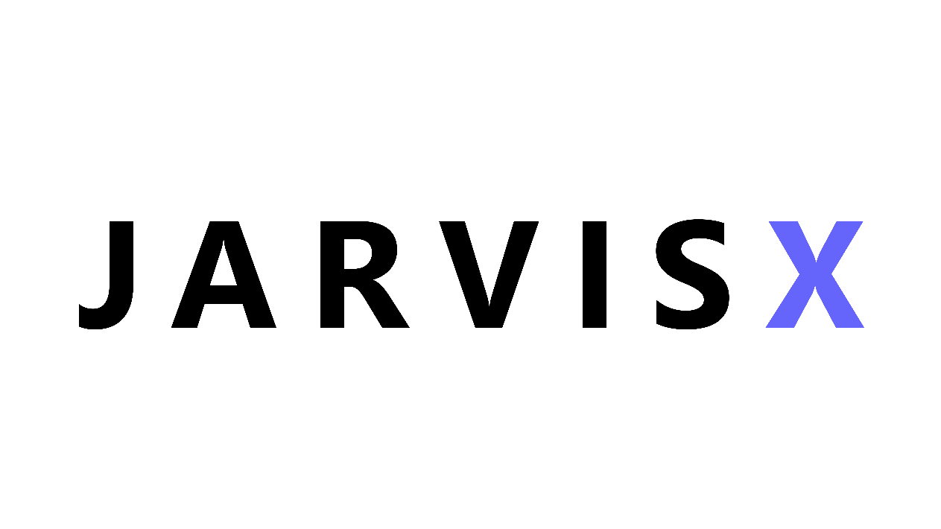

**Team:**

* M.Ahmed Qamar Registration number FA20-BSE-071 is responsible for managing database connectivity.
* M.Ehtasham-Ul-Hassan Registration number FA20-BSE-080 is managing the Graphic User Interface with help of coding. He is a Graphic designer and doing design on Figma.
* M.Moaaz Murtaza number FA20-BSE-084 is responsible for the back end. The documentation will be a combined effort.

**Vision:**

The purpose of our software is to help freelancing agencies manage their projects with ease. The software is based on a system that can store data of freelance projects from multiple sources at a time. The software works two-sided, Client and Freelancer side. Freelancers can add projects accordingly while their clients can keep track of their respective projects with project IDs provided to them. The project will make it easy for small as well as large-scale freelance agencies to keep track of their projects and grow more using the time they would rather waste in managing their ongoing projects hence making the growth of the freelance market skyrocket.

**Scope and Reason of Creation:**

The project will make it easy for small as well as large-scale freelance agencies to keep track of their projects. Analysis shows that there is a huge market gap for such software. The software will benefit small-scale agencies the most. As a free launcher, we face huge miss management because we have to be active on all platforms like Upwork, Freelancer, Fiverr, etc. That’s why we decided to make software to fill this gap.

**Functionalities:**

* To store multiple projects.
* Assigning the projects.
* Tracing project·
* Status assigned to projects.
* Project Status

**Tools:**

* Figma for logo designing.
* For GUI and Back end, we are using JAVA.